INTRODUCTION:

What is Sourcerer ?

Sourcerer Instrument Control Software lets you start making measurements in minutes without complex instrument programming .It allows you to do I-V characterization, data acquisition and logging, and power supply control on a variety of Keithley sourcemeter model 2400.The software controls instruments through the standard USB Interface. Data can be displayed in a graph format.All data can be stored in css files and can be exported using emails directly through the software for further analysis.

About the User manual:

This guide contains basic instructions for the Sourcerer software. Additional information specific to the Keithley Sourcemeter model 2400 is available on the Keithley Instruments website at [www.tek.com/keithley](http://www.tek.com/keithley).

Contact information

If you have any questions regarding the Sourcerer software after you review the information in this manual, please contact the following developers:

Akash Kumar Ahirwar :

Amey Kiran Patel :

Chinmay Anand :

Mohit Malviya :

Sandharb Sahu :

Connecting Keithley to computer

Identifying sourcemeter through software

* Signing up and Logging in :

The first window which appears after launching Sourcerer is the login window through which u can log in to the software and gain access to your previously done work.

-For logging in just enter your <username> and <password> in the space provided in the login window and click on the “LOGIN” button to log in .

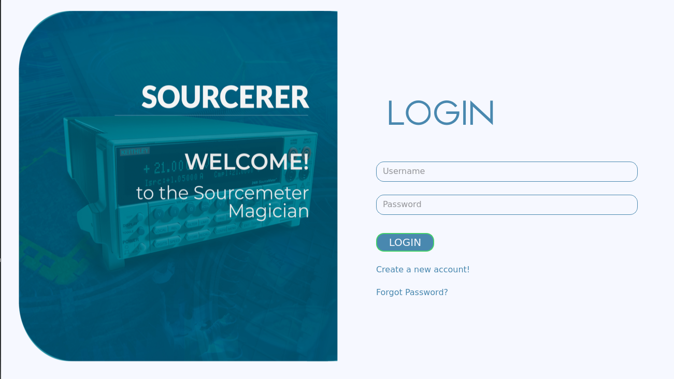

* Forgot Password:

If the user forgets the password to his/her account he/she can use the “forgot password” functionality to retrieve the password.

1. Click on “forgot password”
2. A new window opens, Fill yr email-Id linked to your account in the pace provided
3. Click Recover ,your Password will be emailed to you on this email-ID

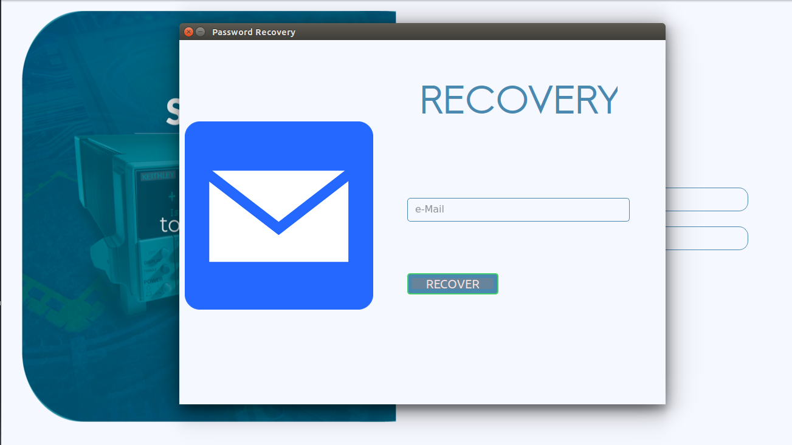

* If operating Sourcerer for the first time, you’ll need to create your account.

To create a new account:

1. Click on the “Create a new account” button.
2. The Sign Up page opens with details such as your name, username, email-ID and password. Fill in the details and click on the “SIGN UP” button to create your new account.

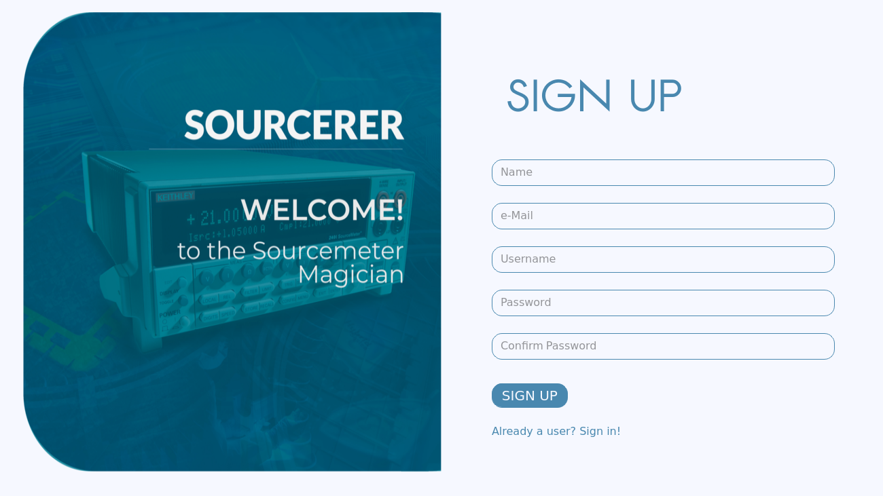

* Regulating Voltage

The system function of Sourcerer is to be able to regulate the voltage through sourcemeter as per the wish of the user.

There are 3 different voltage specifications available in the software.

1. Constant Voltage
2. Sinusoidal Voltage
3. Linearly Variable Voltage

To Apply any of the above voltage:

1. Select the sourcerer tab from the 3 tabs on the top of the window
2. Select the desired voltage specification
3. After selecting one amongst the 3 voltage specifications available the corresponding fields are displayed to fill
4. Fill details according to the selected voltage specification after going through the following information about them
5. Constant Voltage

Applies constant voltage value across the sample throughout the experiment.

* Value : Refers to the value of the constant voltage (in Volts) user wishes to apply using the sourcemeter across the sample
* Duration of Experiment: Refers to the amount of time(in minutes) for which the constant voltage is to be applied to across the sample

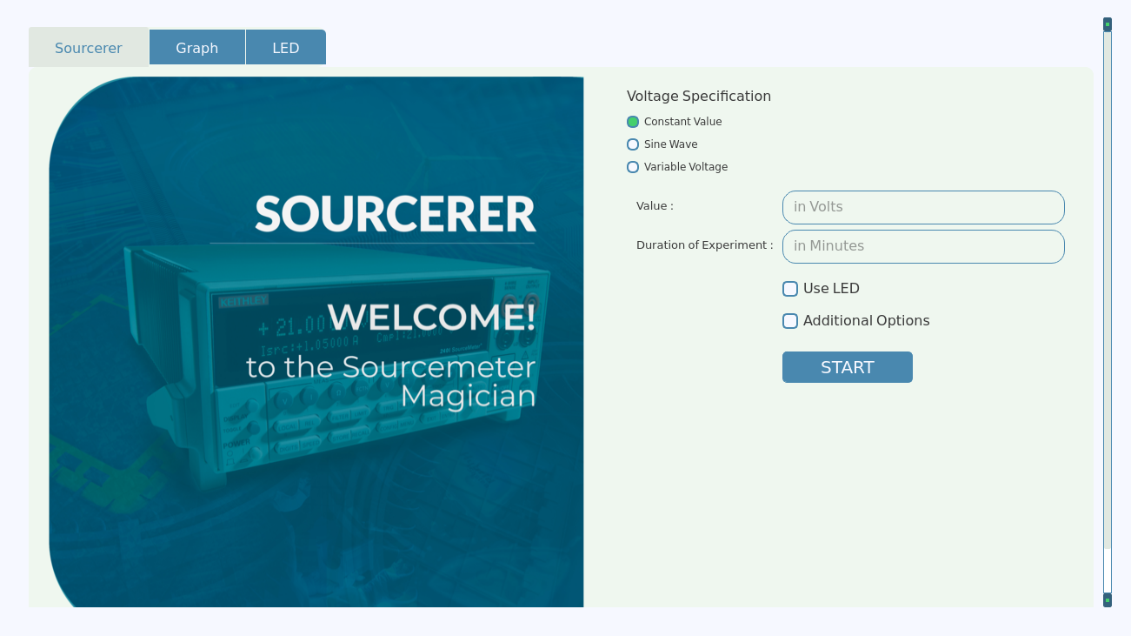

For e.g. if the user wants to apply a voltage of 5 volts for 3 mins the user fills 5 in the value box and 3 in the duration box.

1. Sinusoidal Voltage

Applies voltage in the form of sinusoidal wave.

If the wave is depicted by the function

f(t)= A sin( ν t + φ)

where (φ) represents the initial phase of the sin wave in degrees, (ν) refers to the frequency of the wave and (A ) represents the amplitude of the wave

* Initial Phase(φ) : Initial phase refers to the phase of the sinusoidal voltage wave at the start of the experiment (in degrees)

tips:

For the initial voltage value to be 0 fill phase as 0

For the initial voltage value to be half of the peak value fill phase as 30.

For the initial voltage value to be the peak voltage value fill phase as 90

* Frequency(ν) : frequency (in second-1) refers to the no. of wave cycles the wave completes in 1 second
* Amplitude(A) : Amplitude (in voltage) refers to the highest magnitude the wave achieves in one complete cycle.

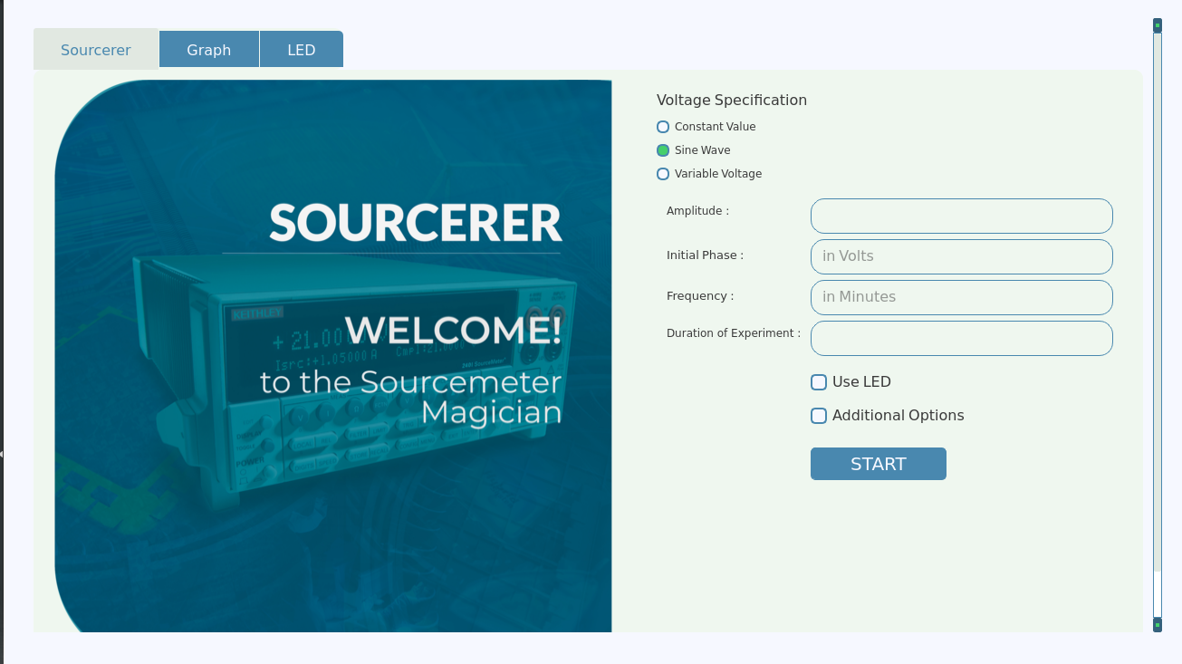

For e.g. if the user wants the wave to attain maximum of 5 volts,oscillate 10 times in a second and start from amplitude i.e. 5 volt the user will enter the wave 5 in amplitude box,10 in frequency box,and 90 in intial phase box

1. Linearly variable voltage :

Applies the voltage in form of either linearly increasing or linearly decreasing function depending on the intital and final value specified by the user.

* Start Value: The initial value of the voltage the user wishes to apply.
* Final value: The final value of the voltage the user woshes to apply.
* No. of steps: A step refers to no. of small increments or decrements needed to get to the final voltage from the initial voltage the voltage applied i.e. if no. of steps = 10 then the voltage will go from initial to final voltage in 10 incremental or decremental steps.

Note: In each step, change occurring in the voltage

= (final value-initial value)/no. of steps.

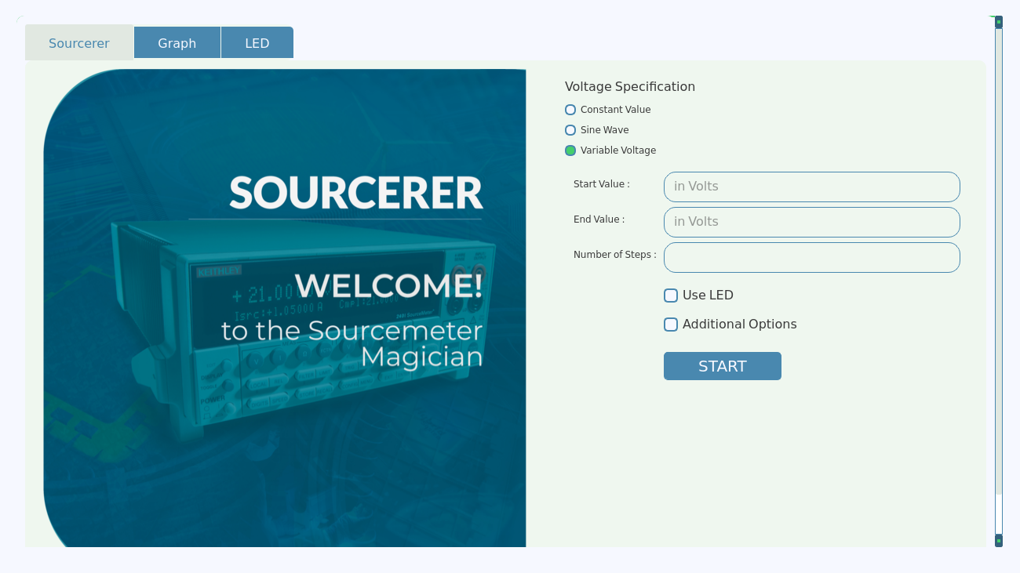

For e.g. if the user wan,ts the voltage to start from 5 volt and finally reach 8 volt in 3 steps i.e voltage alue at each consecutive steps would be 5, 6, 7, 8 ; the user will input 5 as start value,8 as final value and 3 as no.of steps.

1. Click on “START” button to start the experiment.

* Extra options available:
* Voltage Range: Refers to the maximum voltage a voltage source can apply across the load. Enables the user to provide a maximum limit to the voltage that can be applied to across the sample. Useful when the user knows that the sample may damage if higher potential is applied across it; in such situations the user can set a safe voltage limit. The sourcemeter won’t allow voltage higher than this to be applied preventing any damage to the sensitive sample.
* Compliance: Similar to the voltage range, compliance here refers to the maximum current a voltage source can apply across a load. So the user can apply a safe current limit below which the sample won’t experience any damage.
* Resistance Range:

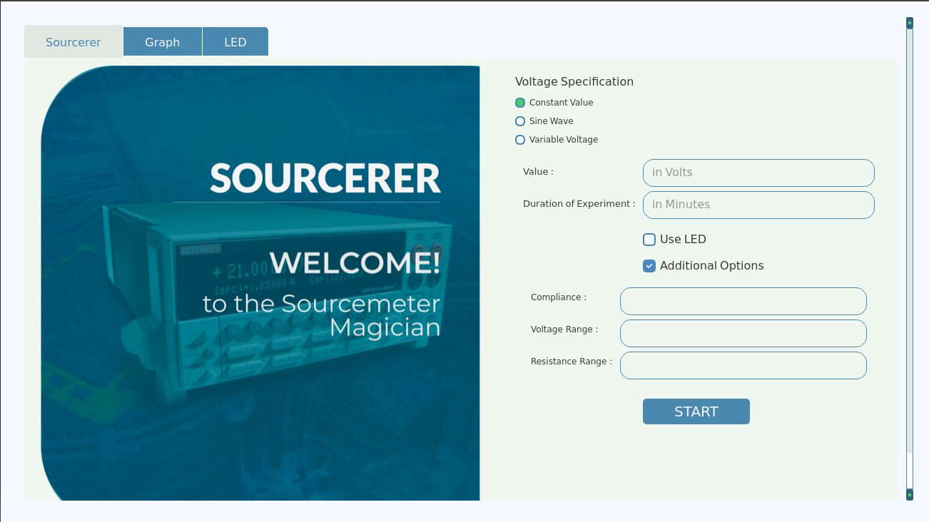

To set Voltage Range:

1. Select the textbox next to the tag “ Voltage Range ”
2. Type the numerical value (in Volt)of desired maximum limit of voltage ,the limit will be set to that value.

To set Compliance:

1. Select the textbox next to the tag “ Compliance ”
2. Type the numerical value (in ampere) of desired maximum limit of voltage ,the limit will be set to that value.

To set Resistance Range:

1. Select the textbox next to the tag “ Resistance Range ”
2. Type the numerical value (in Ohms) of desired maximum limit of voltage, the limit will be set to that value.

* Using LED :

Sourcerer can be used to control a light source in form of a LED to observe changes due to exposure of light on the sample.

To use LED:

1. Repeat the process of regulating voltage till step 3 to set up the experiment.
2. Before clicking on the start button select the “USE LED” option.
3. Click on “START” button
4. A window will open regarding the operating details of the LED

The LED has 2 states, ON and OFF. So the LED is Oscillated in between these two states.

* On time: ON time (in seconds) refers to the time duration for which the LED remains ON and emits light.
* Off time: Off time (in seconds) refers to the time duration for which the LED remains OFF and does not emit light.
* Duration: Duration (in minutes) refers to the total time of the experiment for which the LED keeps oscillating.(NOTE : Once this Duration is over the LED remains OFF)

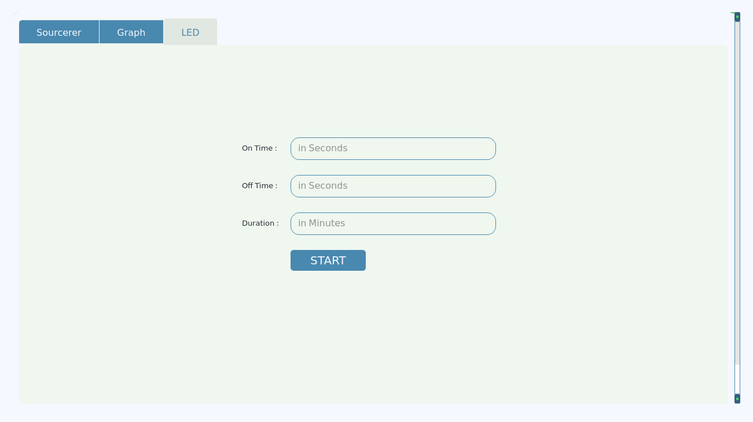

For e.g. if the user wants the LED to oscillate for 10 mins and wants the LED to be ON for 40 seconds and then off for the next 10 seconds user will enter 40 as on time,10 as off time and 10 as Duration.

1. Fill the corresponding details and Click on “START” button to start the experiment.

* Viewing and Saving Results

1. After the experiment is completed, open the Results tab from the top of the window.
2. The results and the measurements are recorded in the table in this tab for the user to see and analyse.

The table has 4 columns;

* Time : the time at which the measurement of current voltage and resistance were taken (taking time at the start of the experiment to be 0)
* Voltage : the voltage applied across sample at the time mentioned in the time column
* Current : the current measured across the sample at the time mentioned in the time column
* Resistance: the resistance measured across the sample at the time mentioned in the time column

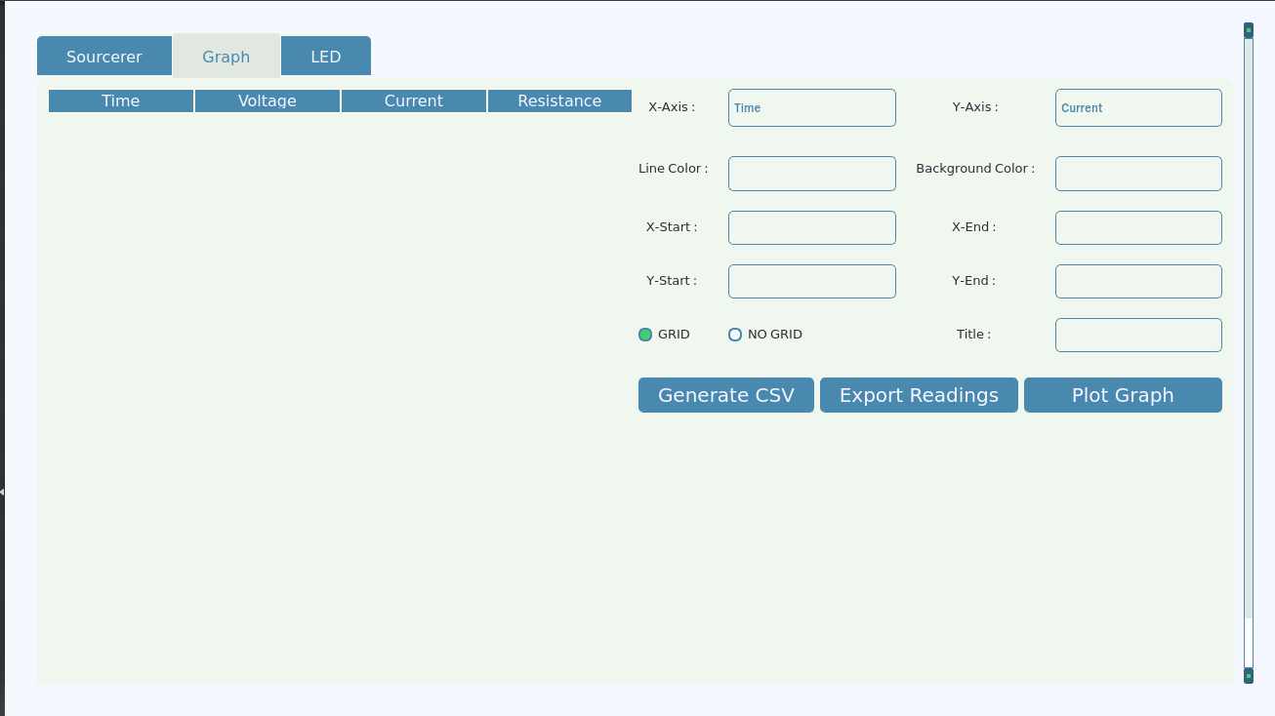

Now these results can be stored for later use in CSV files just by a click of the button.

To save the results in CSV file format:

1. Click on the “Generate CSV” button.
2. Type the name under which you want this file to be saved
3. Set the location of the file where u want it to be saved

(CSV is a simple file format used to store tabular data, such as a spreadsheet or database. Files in the CSV format can be imported to and exported from programs that store data in tables, such as Microsoft Excel or OpenOffice Calc as per user’s wish. CSV stands for "comma-separated values" )

The user can also export the readings through email directly from the software. To export the readings:

* Click on the “Export Readings” button
* A new window appears
* Fill your email-ID and password in the respective boxes
* Click on “Email” button

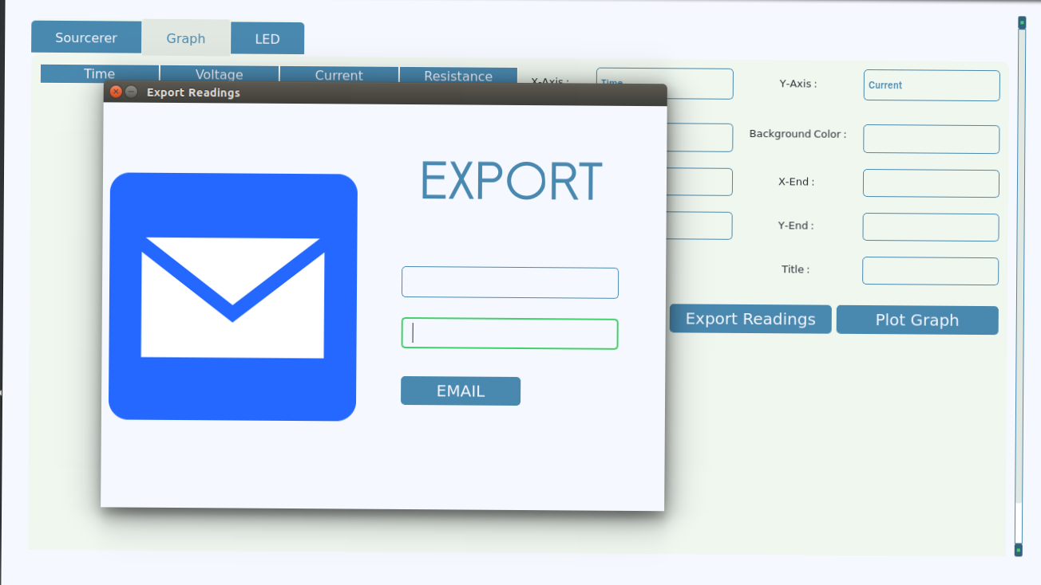

The readings will directly be sent to the specified email

* Plotting graph for analyzing

Sourcerer provides the user with a facility of plotting graphs using the readings observed and recorded from the experiment. As the table contains 4 variables : Time, Voltage, Current and Resistance The user can use t he software to plot a graph between any 2 variables for analyzing their interdependency.



To plot the graph:

1. Select the graph tabs
2. There are different fields to be filled according to which the graph would be plotted

* X-axis And Y-axis:

A drop down menu appears when the user clicks on the box next to the X-axis or the Y-axis options.

As simple as it sounds, the user has to select variables from the 4 available options(Time, Current, Voltage and Resistance) to display on the 2 axes of the graph.

To select the X-axis variables:

1. Click on the variable you wish to select in the drop down menu next to the X-axis option

Similarly to select the Y-axis variables:

1. Click on the variable you wish to select in the drop down menu next to the Y-axis option

Note: The time variable is practically independent of any other variable and the x variable is taken as the independent variable in mathematics, hence the time variable is allowed only to be selected on the X-axis.

* Line color and the Background color:

These 2 options are more for aiding the user customizations. The background color refers to the background color of the graph and the line color refers to the color of the line or the dots marked on the graphs as readings. These options enable the user to choose from a variety of colors what suits him/her the best.

To choose the Line color :

1. Click on the box next to the tag “Line Color” to choose line color for your graph
2. A color pallete opens, select a fitting color from this color palette and click on okay, the Line Color will be selected.

Similarly, to choose the Line color:

1. Click on the box next to the tag “Background Color” to choose line color for your graph
2. A color palette opens, select a fitting color from this color palette and click on okay, the Background Color will be selected.

Note:

1. Select contrasting colors such as black and wite or black and green or white and blue for better visibility of the graph.
2. If no colors are selected the default colors will be displayed in the graph.

* Grid :

Grid are group lines running perpendicular to the axes which helps the user visually to easily find out which values a reading on the graph represents.

1. For enabling grid just click on the circle next to the grid option in the window.

Note: By default no grid is shown in the graph.

* Title

The user can give a title to the graph.

1. To give a title, type the desired title in the textbox next to the “title” tag in the widow.